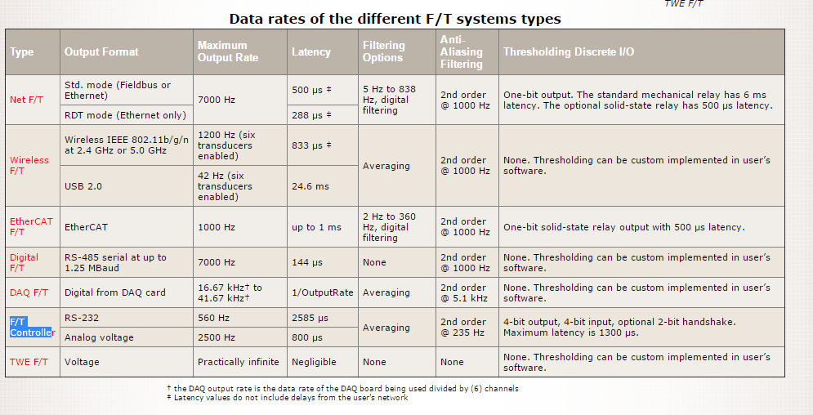
Output Format: Format of the data.
Maximum Output Rate: The maximum number of samples per second received by the user.
Latency: The maximum amount of time it takes for a load to be output and received by the user. The latency data given in the table above is for the maximum output rate. At lower output rates the latency will increase.
Filtering Options: Digital filters available to the user. These may be disabled.
Anti-Aliasing Filter: The type of low-pass filter used to remove high-frequency noise from the transducer's signals.
Thresholding Discrete I/O: Types of discrete I/O to signal the state of user-defined thresholding statements.
Note: Resonance frequencies for transducers are listed with transducer specifications. Frequency response is dependent on sensor tooling mass and configuration, is specific to each application, and if desired is the responsibility of the customer to determine.

F/T Sensor: Gamma
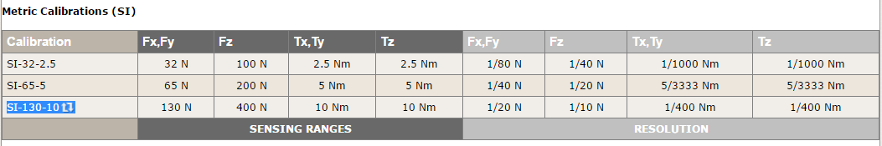
**Resolutions quoted are the effective resolution after dropping eight counts of noise.
***Applied loads must be within range in each of the six axes for the F/T sensor to measure correctly.

ATI's F/T calibrations are traceable to the National Institute of Standards and Technology (NIST). ATI certifies sensors are calibrated in accordance with
applicable ATI procedures. These procedures are compliant with the ISO 9001 standard to ensure that products are within ATI specifications.
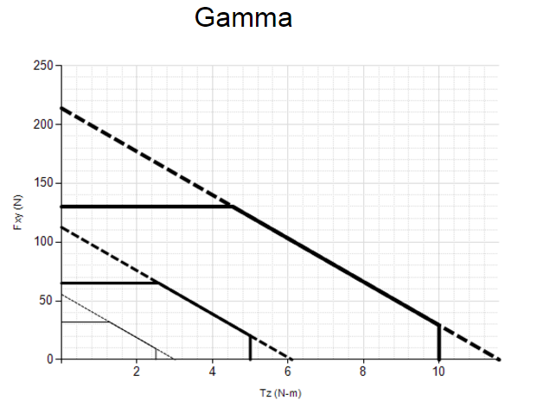
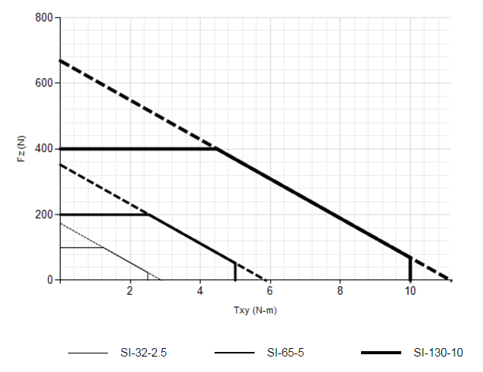
Contact your sales representative for accuracy information.

